A PROJECT REPORT

On

A STUDY ON INDIAN MONEY MARKET

SUBMITTED TO HP UNIVERSITY SHIMLA

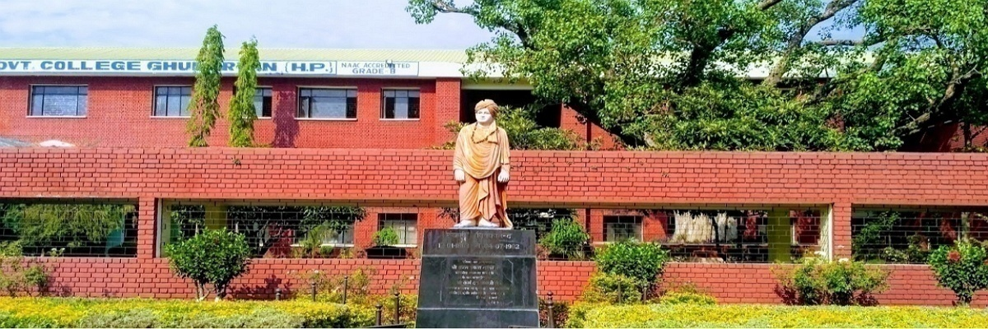

In partial fulfilment of the requirement for the award of the degree

Of

BACHELOR OF BUSINESS ADMINISTRATION

SWAMI VIVEKANANDA GOVT. COLLEGE GHUMARWIN

SESSION 2021-2022

SUBMITTED TO: SUBMITTED BY: Shivani

Mr. Naresh kumar

Assistant Professor

UNIV. ROLL.5190350028

**DECLARATION**

I **Shivani** hereby declare that the project report was submitted by me under the supervision and guidance of ASST. PROF. Mr. Naresh kumar, project guide college of **SWAMI VIVEKANAND GOVERMENT COLLEGE, GHUMARWIN** in partial fulfilment of BBA 6th semester. I further declare that I am solely responsible for omission and commission of errors if any.

Signature

Shivani

University Roll no. 5190350028

DATE -

**ACKNOWLEDGMENT**

“Acknowledgement is an art, one can write glib stanzas without meaning a word, on other hand one can make a simple expression of gratitude” I take the opportunity to express my gratitude to all of them who in some or other way helped me to accomplish this challenging training in “**A STUDY ON INDIAN MONEY MARKET IN (HP)”** no amount of written expression is sufficient to show my deepest sense of reference to Principal PROF. Ramkrishan, Coordinator ASST. PROF. Mr. RAJENDER Kumar and Assistant professor Mr. Naresh kumar (Project Guide). I also express deepest gratitude to my family for their blessing and good wishes.

I also acknowledge with a deep sense of reverence, my gratitude towards my parents and my friends who directly or indirectly help me.

Shivani

**CERTIFICATE**

This is to certify that the report entitled “A STUDY ON INDIAN MONEY MARKET” for the award of the degree of Bachelor Of Business Administration (BBA) from SWAMI VIVEKANAND GOVT. COLLEGE, GHUMARWIN (HP), Is a record to project report carried out by **SHIVANI BBA 6TH Sem. UNIV. ROLL No.5190350028** under my supervision and guidance, no part of this report has been submitted to any other Degree /Diploma and this report may be taken for evaluation.

**Sign of Student**

**Sign of Guide**

**Sign of Coordinator**

Date-

Place- Ghumarwin

TABLE OF CONTENTS

|  |  |  |
| --- | --- | --- |
| SR.NO. | TITLE OF THE CHAPTER | PAGE NUMBER |
| 1 | INTRODUCTION TO THE TOPIC |  |
| 2 | Research methodology |  |
| 3 | Data analysis & interpretation |  |
| 4 | Finding suggestions and Conclusion |  |
| 5 | Questionnaire |  |

CHAPTER 1

INTRODUTION TO THE TOPIC

INTRODUCTION PREPERATION OF MONEY MARKET ANALYSIS:



**Meaning and Definition: -**

Money market refers to the market where money and highly liquid marketable securities are bought and sold having a maturity period of one or less than a year. It is not like stock Market, but an activity conducted by telephone.

The market constitutes a very important segment of the Indian financial system. The highly liquid marketable Securities are also called as 'money market instruments' like treasury bills, government securities, commercial paper, certificate of deposit, call money and repurchase agreement etc.

The players in the money market are Reserve Bank of India (RBI), Discount and Finance House of India (DFHI), banks, financial institutions, mutual funds, government, big corporate houses. The basic aim of dealing in money market instruments is to fill the gap between the short-term liquidity problems or to use the Short-term surplus to gain income on that.

**Definition of money market: -**

**According to the Reserve Bank of India,** “money market is the center for dealing, mainly of short-term character, in money assets; it meets the short-term requirements of borrowings and provides liquidity or cash to the lenders. It is the place where short term surplus investible funds at the disposal of financial and other institutions and individuals are bid by borrowers’ agents comprising institutions and individuals and the Government itself.”

**According to the Geoffrey,** “money market is the collective name given to the various firms and institutions that deal in the various grades of the near money.

**Objective of money market: -**

The following are the important objectives of a money market:

*To provide a parking place to employ short-term surplus funds.

*To provide room for overcoming short-term deficits.

*To enable the Central Bank to influence and regulate liquidity in the economy through its intervention in this market.

*To provide a reasonable access to users of Short-term funds to meet their requirements quickly, adequately and at reasonable costs.

**General Characteristics of Money Market: -**

Money market is the short-term money market where financial assets that are the close substitute of money. Money market can exist anywhere where borrowers and lenders desire to enter into short term credit transaction as in any other market. Money market also has three constituents like any other market —

(I) Money market has buyers and sellers in the form of borrowers and lenders.

(2) It has a commodity in the form of instruments like Treasury Bills and Commercial Paper etc.

(3) It has a price in the form of rate of interest.

The term “Money Market” refers to the various firms and institutions dealing with several types of “near money”. Near money consists of assets which can be converted into cash without any loss.

One of the features of money market is that it is not a one market but the collection of markets such as call and notice money market and bill market etc. All these markets have close inter-relationships.

An ideal money market is one where there are enormous numbers of participants. Larger is the number of participants greater is the depth of the market. It’s only the money market which solves the problem.

If the problem is that of cash out flow more than cash receipts, they go to the money market looking for funds. If the problem is that of excess cash inflow, then the problem is again set off by money market for temporary fund deployment. Thus, it is the money market which meets short-term requirements of borrowers and provides profitable avenues to the lenders.

The term money market is also known as a wholesale market. The volumes of funds, traded in the market, are very large. There are skilled personnel to undertake the transactions. Trading in the market is attends beyond the telephone followed by written confirmation from both the borrowers and lenders.

Depending on supply of funds, Indian Money Market is divided into two markets:

(a) The organized money markets

(b) The unorganized money markets.

The participants in the organized money market are the Reserve Bank of India (RBI), Commercial Banks, Co-operative Banks, Unit Trust of India (UTI), Life Insurance Corporation of **India** (LIC), General Insurance Company (GIC). Discount and Finance House of India (DF HI), Industrial Development Bank of India (IDBI), National Bank of Agriculture and Rural Development (NABARD),

Industrial Credit Investment Corporation of India (ICICI), corporate bodies The RBI has close links with money market and it can justly be regarded as an important constituent of money market as it plays the vital role of controlling the flow of currency and credit in the market. The unorganized sector consists of indigenous bankers who engage the banking business traditional lines. Indigenous bankers follow their own rules of banking and finance. Attempts have been made by RBI to bring them under the organized market. But indigenous bankers as an aggregate not accepted the conditions prescribed by RBI. The instruments in the money market are call money’, Treasury Bills, Commercial Bills, Commercial Paper, Certificate of Deposits, Interbank Participation.

(a) The primary market.

(b) The secondary market.



In order to enable the small investors to get access to the money market so as to benefit from its yields, the Reserve Bank of India has issued broad guidelines to allow banks and the subsidiaries to set up Money Market Mutual Funds (MMMF) similar to mutual funds for stock market. MMMFs pool the investor funds through MMMF Unit/deposit account and invest this fund in money market instruments.

With the liberalization and deregulation process initiated by RBI, several innovations have been introduced. But even then, the money market is not free from the following rigidities:

▪ Absence of **integration**

▪ Disparity of interest rates in different center

▪ Resistance of the unorganized money market

▪ High volatility

▪ Restricted/Limited number of players

▪ Limited number of instruments

▪ Absence of transparency in transactions

▪ Inefficient payment system

**Efficient Money Market:-The Conditionalities**

Political stability in the country

Presence of highly organize 5 commercial banking systems.

Effectiveness of central banking authority

Existence of demand for temporary surplus funds

No fixed place for conduct of operations, the transactions can be conducted even on the phone and therefore, there is an essential need for the presence of well-developed communications system.

Dealings can be done with or without the help the brokers.

The short-term financial assets that are dealt in are close substitutes for money, financial assets being converted into money with ease, speed, without loss and with minimum transaction cost.

Funds are traded for a maximum period of one year.



**History of Indian Money Market: -**

Till 1935, when the RBI was set up the Indian money market remained highly disintegrated, unorganized, narrow, shallow and therefore, very backward. The planned economic development that commenced in the year 1951 market an important beginning in the annals of the Indian money market The nationalization of banks in 1969, setting up of various committees such as the Sukhoi Chakraborty Committee (1982), the Vague working group (1986), the setting up of discount and finance house of India ltd. (1988),the securities trading corporation of Improvise (1994) and the commencement of liberalization and globalization process in 1991 gave a further fillip for the integrated and efficient development of India money market.

Call money market is the oldest in the history of money market in India which provides the institutional arrangement for making the temporary surplus of some banks available to other banks which are temporarily in short of funds.

The rate of interest paid a call loans is known as the call-rate. The call rate in

India was used to be determined by market forces till 1973. Due to the credit squeeze introduced by RBI in May 1973 in the form of raising 'he bank rate and tightening of refinance and rediscounting facilities, the call rate had reached as high a level as 30% in Dec. 1973. Due to this alarming level of call rate it became necessary to regulate it within a reasonable a limit.

Therefore, the Indian Bank Association in 1973 fixed a ceiling of 15% on the level of call rate. Since the IBA has lowered the ceiling of 15% to 12.5% in March 1976, 10% in Jane 1977, 8.65 in March 1978 and 10% in April 1980. In India the call rate has always exceeded the bank rate except in the freak year 1955-66. The difference between two rates increased as the RBI tightened its refinancing an5 rediscounting facilities till 1975-76.

In 1980-81, the call rate was much higher than the bank rate. After 1981, call rate was slightly higher than the bank rate.

After Discount and Finance House of India (D.F.H.I.) commenced its operation in April 1988, it was permitted by R.B.I. to act as an arranger of funds in the call market. However, with effect from 28th July 1988, it has been allowed to participate both as the lender and as borrower in the call notice market. The call rate has seen freed from administrative ceiling in 2 stages.

Effective from October 1988, the operations of D.F.H.I., in the call market where exempted from the ceiling on the call rate.

With effect from.1" May 1989, the callings in the call rate and interbank term money rate were withdrawn. As a result, the call rate ns freely determined by the forces of demand for and supply of call loan. There are now 2 call rates in India one is the inter-bank call rate and the other is the lending rate of D. H.I. in the call market.

The Bill Market Scheme was introduced by RBI in January 1952, before 1952, the banks were getting additional cash from RBI by selling their government securities. But now according to bill market scheme, a bank can grant loan to its customers against their promissory notes and it can use the same promissory notes to borrow from the Reserve Bank. All that the Bank is required to do is to convert these promissory notes into promissory notes maturing within 90 days. Initially it was restricted to (a) the schedule bank with a deposit Rs.10 crores and above, (b) loans with minimum limit of Rs.10 lakhs (c) individual bills, the minimum value of each being 1 lakh rupees.

The scope of the scheme was broadened from time to time.

⮚by making more banks eligible to borrow under the scheme

⮚ by reducing the minimum limit of advances.

⮚ by reducing the minimum eligibility value of bills.

⮚ by extending the scheme to export bills with minimum of 180-Days.

The bill market scheme became so popular that the turnover under the scheme increased from Rs.29 crores in 1951-52 to Rs.228 crores in 1955-56 and to Rs.1354 crores in 1968- 69. In 1970, RBI instituted Narasimha Committee to study the development of the bill market. In 1970, the new bill market scheme was introduced under sec 17(2) of the RBI

acts.

**Participants: -**

The money market consists of financial institutions and dealers in money or credit who wish to either borrow or lend. Participants borrow and lend for short periods, typically up to twelve months. Money market trades in short-term financial instruments commonly called "paper". This contrasts with the capital market for longer-term funding, which is supplied by bonds and equity.

The core of the money market consists of interbank lending—banks borrowing and lending to each other using commercial paper, repurchase agreements and similar instruments. These instruments are often benchmarked to (i.e., priced by reference to) the London Interbank Offered Rate (LIBOR) for the appropriate term and currency. Finance companies typically fund themselves by issuing large amounts of asset-backed commercial paper (ABCP), which is secured by the pledge of eligible assets into an ABCP conduit. Examples of eligible assets include auto loans, credit card receivables, residential/commercial mortgage loans, mortgage-backed securities and similar financial assets. Some large corporations with strong credit rating issue commercial paper on their own credit. Other large corporations arrange for banks to issue commercial paper on their behalf.

In the United States, federal, state and local governments all issue paper to meet funding needs. States and local governments issue municipal paper, while the U.S.

Treasury issues Treasury bills to fund the U.S. public debt:

∙ Trading companies often purchase bankers' acceptances to tender for payment to overseas suppliers.

∙ Retail and institutional money market funds

∙ Banks

∙ Central banks

∙ Cash management programs

∙ Merchant bank

CHAPTER 2

RESEARCH METHODOLOGY

**Types of Money Market Instruments: -**

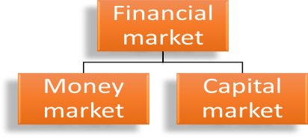

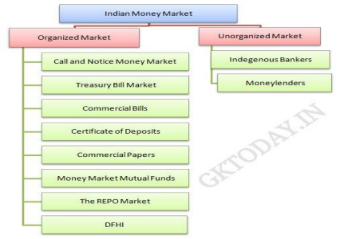

**Structure: -**

The Indian money market consists of two main sectors: -

**1) ORGANISED SECTOR: -**

∙ The RBI is the apex institution that controls and monitors all the organizations in the organized sector.

∙ Also, the organized money market is composed of various components/ instruments that are highly liquid in nature.

∙The instruments traded are call money, treasury bills, commercial bills, certificate of deposits, commercial papers, repos etc.

The organized money market is further diversified with the establishment of the Discount and finance House of India, and Money market Mutual Funds.

**The Instruments of the Organized Money Market Are:*-***

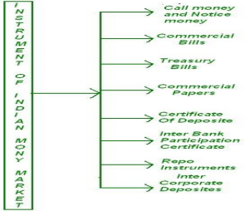

(I) CALL MONEY AND NOTICE MONEY MARKET:

∙The call money market is the most important segment of the Indian money market. It is also called as inter-bank call money market.

∙Under call money market, funds are transacted on an over-night. Generally, banks rely on call money markets where they raise funds for a single day.

∙The notice money market funds are transacted for a period of 2 to 14 days. The loans are to be repaid at the option of either the lender or the borrower.

∙The rate at which funds are borrowed / lent in this market is called the call money rate.

∙The main participants in the call money market are commercial banks (excluding RRBs), co-operative banks and primary dealers.

∙ The Discount and finance House of India and non-banking financial institutions like LIC, GIC, UTI, NABARD, etc., also participate in the call money market. ∙ Call money markets are generally concentrated in large commercial center like Mumbai, Delhi, Chennai, Kolkata and Ahmadabad.

∙ The RBI intervenes in the call money market because it is highly sensitive, and it is the indicator of liquidity position in the organized money market.∙ The call money rate (that depends on depends on demand for and supply of funds) is highly variable from day to day and from center to center

***ii)*** *TREASURY BILLS MARKET:*

. Treasury bills are short-term securities issued by the RBI on behalf of the Government of India.

∙ Treasury bills are of three types: 91-day treasury bills, 182 days treasury bills and 364-day treasury bills.

∙ Since these bills are issued through auctions, interest rates on all types of treasury bills are determined by market forces.

∙ Treasury bills are highly liquid and are readily available.

∙They give assured yields at a low transaction cost.

∙ Treasury Bills are eligible for inclusion in the SLR.

∙ Moreover, they have negligible capital depreciation.

∙ Treasury Bills are available for a minimum amount of Rs 25000 and in multiples of RS 25000.

∙ Treasury Bills are traded in the secondary market. Commercial banks, Primary Dealers, Mutual Funds, Corporate, and Financial Institutions, Provident /

Pension funds and Insurance companies participate in the treasury Bills Market.

∙ However, Treasury Bills Market in India is very narrow and undeveloped.

iii) COMMERCIAL BILLS:

A commercial bill is a short- term, negotiable, self–liquidating instrument drawn by the seller on the buyer for the value of goods delivered by him.

∙Such bills are called trade bills / bills of exchange and when they are accepted by banks, they are called commercial bills.

∙Generally, the bill is payable at a future date (mostly, the maturity period is up to 90 days).

∙During this period, the seller may discount the bill with the banks The commercial banks may rediscount these bills with FIs like EXIM bank, SIDBI, IDBI, etc.

∙ Thus, commercial bills are very important for providing short-term credit to trade and commerce.

iv) CERTIFICATES OF DEPOSITS: (CDs): -

∙ Certificates of Deposits are unsecured, negotiable promissory notes issued by commercial banks and development financial institutions.

∙ CDs are marketable receipts of funds deposited in a bank for a fixed period at a specified rate of interest.

∙They are highly liquid and riskless money market instruments. ∙ CDs were originally introduced in India to enable commercial banks to raise funds from the market.

The RBI has modified its original scheme for CDs. the following are the recent guidelines for the issue of CDs: -

1. ELIGIBILITY: CDs can be issued by commercial banks (except RRBs and Local Area Banks) and financial institutions that have been permitted to raise short-term loans by RBI.

b. AMOUNT: while banks can issue CDs depending on the requirements, financial institutions can issue CDs within the limit fixed by the RBI.

MINIMUM SIZE: the minimum size of an issue for a single investor is Rs 1 lakh and it can be increased in multiples of Rs 1 lakh.

C. DISCOUNT RATE**:** CDs are issued at a discount to face value. Bank / Financial institutions are free to determine discount rates on floating rate basis. c. INVESTORS: CDs are issued to individuals, corporations, companies, trusts, etc.

d. TRANSFERABILITY: CDs are freely transferable by endorsements / delivery. However demitted CDs have to transfer as per specified procedures. There is no lock-in period for CDs.

e. MATURITY: Commercial banks can issue CDs with a maturity period between

7 days to 1year. Financial institutions can issue CDs with a maturity period between1 year to 3 years.

RESERVE REQUIREMENTS: CDs are subject to CRR and SLR since banks have to report CDs to RBI.

f. LOANS / BUY-BACK: Commercial banks / FIs cannot give loans against CDs. Similarly, they cannot buy-back their own CDs before maturity period. g. FORMAT: Banks /FIs should issue CDs only in the dematerialized form. However, investors have the option to seek CDs in physical form. ∙ Due to absence of a well-developed secondary market in CDs, the size of CD market in India is quite small.

v) *COMMERCIAL PAPERS:*

∙ Commercial paper is an unsecured, highly liquid money market instrument in the form of a promissory note / a dematerialized form through any of the depositories registered with SEBI.

∙It has fixed maturity whereby the purchaser is promised a fixed amount at a future date.

∙ Commercial papers are issued by leading nationally reputed manufacturing and finance companies (Public / private sector).

∙They are issued on a discount to face value.

∙ Commercial papers are issued (by corporate / primary dealers / all India financial institutions) on the following conditions:

a) The tangible net worth of the issuing company should not be less than RS4crores.

b) The working capital limit of the company has been sanctioned by banks /financial institution.

c) The borrowable a/c of the company is rated as a standard asset by banks /financial institutions.

d) All eligible participants should have a minimum rating P2 from CRISIL. ∙ Commercial Papers have maturity period between 7days and 1year from the date of issue.

∙ CPs are issued in denominations of Rs 5 lakhs (minimum) or multiples of Rs5 lakh

∙ Individuals, banks, corporate bodies, NRIs and FIIs can invest in commercial papers

∙Every issuer must appoint an 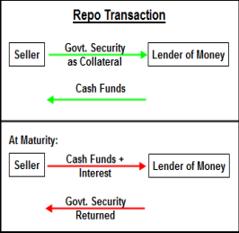

IPA (Issuing and Paying

Agent) for issuance of

commercial papers.

**Review of Literature: -**

***Reuters*** *(2009) Article: India call money ends near reverse repo rate, cash* abundant*.* India overnight money rates brought down to the reverse repo rate of 3.25% on Wednesday these cash surplus in the system will help the banks meet their reserve needs comfortably. Cheaper money usable at the security borrowing and lending agreement (CBLO) also reduce the pressure on the inter-bank cash rates. On that day banks were guided to report their position to RBI once in two weeks. This alteration created an expectation on liquidity resistance. And some analysts said that the central bank may start rolling back the liquidity as early as on December 2009, as they already pressured the consumer prices could pose significant inflationary threat to the economy, in the thick of easy cash conditions Overnight rates are supported around the reverse repo rate because banks holding the surplus funds could also break up with the same central bank at that rate in its daily liquidity adjustment auctions.

***Rastogi Nikhil*** (2008) Article: Money Market Integration in India: A Time Series Study Says that Indian financial markets have achieved much from the highly controlled pre-liberalization era. He denotes that the main focus is on achieving efficiency, which is the trade mark of any developed financial market. This research paper tests the efficiency and extent of integration between financial markets observed at the short end of the market.

The rates are mainly taken for the purpose of the study of, the compound call market rate, CD (Certificate of Deposit) rate, CP (Commercial Paper) rate, 91-day T-bill (Treasury bill) rate and 3-month forward premium.

The results, though promising, are mixed. In his research he concluded that although markets have achieved integration in some of its branches, but they still have to attain full integration.

It has absolute implications on the monetary policy of the Reserve Bank of India. (RBI) since the changes in one market (gilt market) can be used to coordinate the other market (forex market).

**Rusty Sadananda** (2007) Article: Market efficiency and financial markets integration in India in their work examined the impact of economic reforms on the integration of various segments of the financial market in India over the time series tools during the period from March 2006 to March 2012. The major findings were: (I) various sector of the financial market in India have achieved market efficiency, (ii) the 91-day Treasury bill rate is the suitable 'base rate' of the financial sector in India,

(iii) The financial markets in India are broadly integrated at the short-end of the market, and

(iv) The long- end of the market is amalgamate with the short-end of the market. From the above monetary policy should rely more on interest rate and asset price channels to control inflation.

**Recommendations of Three Committees: -**

The issue of whether non-bank participants should constitute part of call/notice/term money market could be traced first in the Report of the Committee to Review the Working of the Monetary System (Chairman: S. Chakravarty) in 1985. Since then, the Report of the Working Group on the Money Market (Chairman: N. Vague) in 1987 and the Report of the Committee on Banking Sector Reforms (Chairman: M. Narasimha) in 1998 had also deliberated on this issue. It needs to be appreciated that the particular set of recommendations from these three Committees have to be assessed against the specific objectives for which these Committees had been constituted as well as the differing initial conditions reflecting the state of Indian financial market which were prevailing at that particular point of time.

**Sukhmoy Chakravarty Committee** (1982) *Articles: - Recommended for call money market* Examined the study of call money market for India was first recommended by the Sukhmoy Chakravarty. Committee was set up in 1982 to review the working of the monetary system. They felt that allowing additional non bank participants into the call market would not dilute the strength of monetary regulation by the RBI, as resources from non-bank participants do not represent any additional resource for the system as a whole, and their participation in call money market would only imply a redistribution of existing resources from one participant to another. In view of this, the Chakravarty Committee recommended that additional nonbank participants may be allowed to participate in call money market.

***The Vaghul Committee*** (1990) Articles: - Introduction of money market instruments.

The Vaghul Committee (1990), while recommending the introduction of a number of money market instruments to broaden and deepen the money market, recommended that the call markets should be restricted to banks. The other participants could choose from the new money market instruments, for their short - term requirements. One of the reasons the committee ascribed to keeping the call markets as pure inter-bank markets was the distortions that would arise in an environment where deposit rates were regulated, while call rates were market determined.

***Narasimham Committee*** (1998) Articles: - observation on call/money/term money market examined the Narasimham Committee II (1998) concurred with the Vaghul Committee as it also observed that call/notice/term money market in India, like in most other developed markets, should be strictly restricted to banks. It, however, felt that exception should be made for Primary Dealers (PDs) who have been acting as market makers in the call money market and are formally treated as banks for the purpose of their inter-bank transactions and, therefore, they should remain as part of call money market.

With regard to non-banks, it expressed concern that these participants "are not subjected to reserve requirements and the market is characterized by chronic lenders and chronic borrowers and there are heavy gyrations in the market". It felt that allowing non-bank participants in the call market "has not led to the development of a stable market with liquidity and depth and the time has come to undertake a basic restructuring of call money market". Like the Vaghul Committee, it had also suggested that the non-bank participants should be given full access to bill rediscounting, Commercial Paper (CP), Certificates of Deposit (CDs), Treasury Bills (TBs) and Money Market Mutual Funds (MMMFs) for deploying their short-term surpluses.

***Kotter and Mosser*** (2002) Articles: - The Monetary Transmission Mechanism: Some Answers and Further Questions examined the Monetary policy’s effect appears to be somewhat weaker than they were in past decades. Financial Innovation is one possible cause of this change but not the only one improved inventory management and the conduct of monetary policy itself are others. Thank to financial innovation and institutional changes in housing finance the housing sector is no longer on the leading edge of the transmission mechanism. However, judging from the evidence presented for the United. Kingdom, the role of housing assets on households’ balance sheets warrants further study. Neither financial consolidation nor the shrinking reserve volume appears to be a major factor affecting monetary transmission—at least not yet.

Some loose ends and lacunae remain, however.

First, although monetary policy seems to have retained its effectiveness, the economy’s sensitivity to interest rates remains an open question.

***Conclusion: -***

The call money market decreases the repo rate, but the bank manages the cheaper money of their surplus breakdown through reverse repo rate.

The bank has to report this issue to RBI within to week.

Rastogi says that the Indian money market has achieved more from the pre liberalization era.

In his research he concluded that although markets have achieved integration in some of its branches, but they still have to attain full integration.

He said that the main objective or focus is on creating efficiency or growth of money market.

The monetary policy should rely more on interest rate and asset price channels to control inflation.

The Chakravarty Committee recommended the additional nonbank participants may be allowed to participate in call money market.

The Vaghul Committee introduced the money market and broaden the instrument of money market. The money market is usually for short-term period i.e. less than one year

THE Narasimham Committee study the observation of call and term money Interest are collected periodically by the depositor by depositing.

Because of change in RBI regulation there is change the rate of interest Because of **inflation** there is change in the rate of interest it affects the rate of interest.

**Research Methodology: -**

Methodology is an essential part of research to find answers to the research objectives that initiate the same. Therefore, it figures as an important part of the study. This chapter focuses on the design and research method utilized in the study. In addition, the procedure followed to collect, capture, process and analyzed data is presented. The research approach used in the study is presented below: -

**Sample Unit: -**

Sample size determination is the process of choosing the number of respondents/observations to include in a statistical sample. It is an important feature of a research study because on the basis of sample size data is collected and interpreted to give accurate and appropriate results.

The correct and appropriate sample size is said to give more accurate results. For example, in a census, data is collected from the entire population. Therefore, the sample size is equal to population of the country. Keeping in mind the rate of non-response and non-availability of respondents, the sample size was taken between. It was Random sampling method that was considered to decide the sample size.

Due to the sample size being small there may be slight inaccuracy of data that can be rectified by further study.

**Type of research: -**

My research is based on descriptive research. It helps to know qualitative and quantitative aspects of study. It studies the characteristics of Indian Money Market and see to it that how we can bring more agencies in India. It is used because this topic is being studies only to understand the concept and the problem it faces. However, my research also studies Review of Literature which acts as a base for Descriptive study.

**Sampling Objective: -**

The objectives are designed to have a particular direction to the study like what aspect of the topic is going to be studied. A topic can be studied from various parameter, the objectives designed for a project gives an idea that in what manner the topic is studied, what is the flow of project, what are the variables selected for the project, etc. -To find out individual investors for the age group of 18-55 years.

**Sampled size: -**

Sample size determination is the process of choosing the number of respondents/observations to include in a statistical sample. It is an important feature of a research study because on the basis of sample size data is collected and interpreted to give accurate and appropriate results.

The correct and appropriate sample size is said to give more accurate results. For example, in a census, data is collected from the entire population. Therefore, the sample size is equal to population of the country. Keeping in mind the rate of non-response and non-availability of respondents, It was Random sampling method that was considered to decide the sample size.

Due to the sample size being small there may be slight inaccuracy of data that can be rectified by further study. **(100 respondents)**

***SAMPLE DESIGN: -***

The sample design used to represent the survey data is in the form of Pie-Charts and Bar Charts based on the 100 respondents of the survey. Probability sampling was used to collect responses.

**CHAPTER 3**

**DATA ANALYSIS**

**&**

**INTERPRETATION**

**DATA ANALYSIS:**

**Interpretation and Presentation:-**

1) What is your annual income?

| SR. NO. | PARTICULARS | FREQUENCY | PERCENTAGE |
| --- | --- | --- | --- |
| 1 | Below 1 lakh | 7 | 7% |
| 2 | Between 1 lakh to 3 lakhs | 10 | 10% |
| 3 | Between 3 lakhs to 5lakhs | 15 | 15% |
| 4 | Above 5 lakhs | 38 | 38% |
| 5 | No income | 30 | 30% |

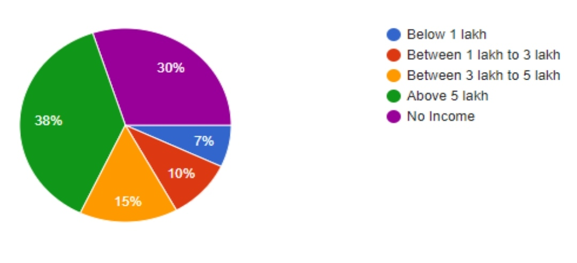

Interpretation: -

There were total 100 responses out of which 7% respondents have annual income of below 1 lakh. 10% respondents have an annual income between 1 lakh to 3 lakhs, between 3 lakhs to 5 lakhs were of 15%, above five lakhs were 38% and for no income there are 30%

2) How do you invest in your saving?

| SR NO. | PARTICULARS | FREQUENCY | PERCENTAGE |
| --- | --- | --- | --- |
| 1 | Invest in capital  market | 49 | 49% |
| 2 | Invest in money  market mutual  fund | 54 | 54% |
| 3 | Invest in bank | 60 | 60% |
| 4 | Invest in real  estate | 20 | 20% |

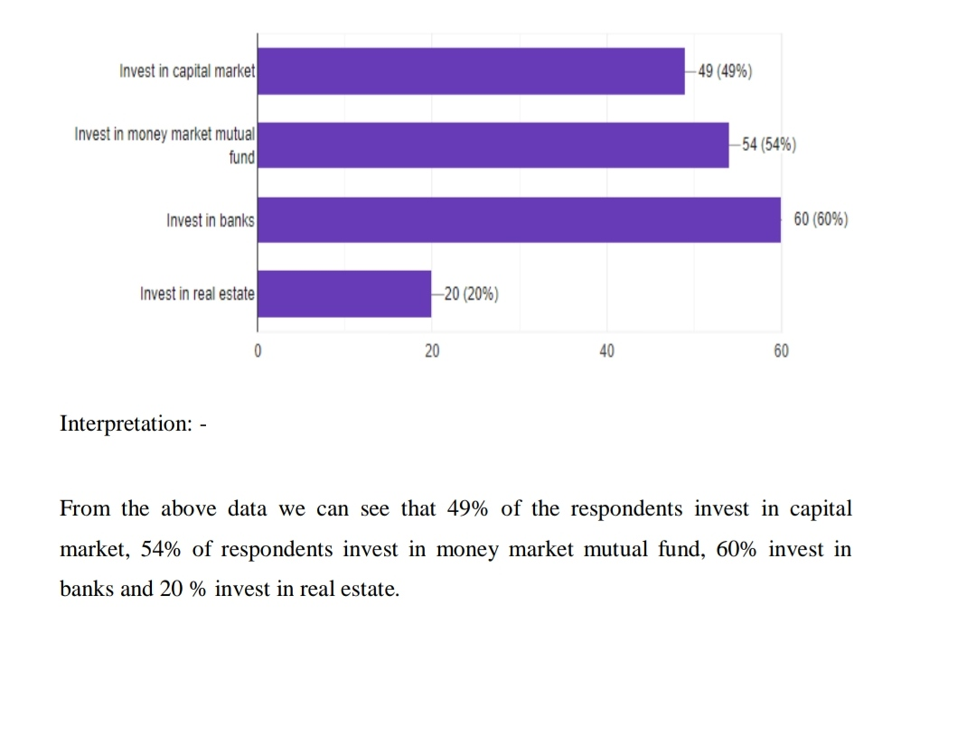

3) Do you have any knowledge about money market instruments?

| SR NO. | PARTICULARS | FREQUENCY | PERCENTAGE |
| --- | --- | --- | --- |
| 1 | YES | 75 | 75% |
| 2 | NO | 8 | 8% |
| 3 | MAYBE | 6 | 6% |
| 4 | HEARD BUT  DON’T KNOW | 11 | 11% |

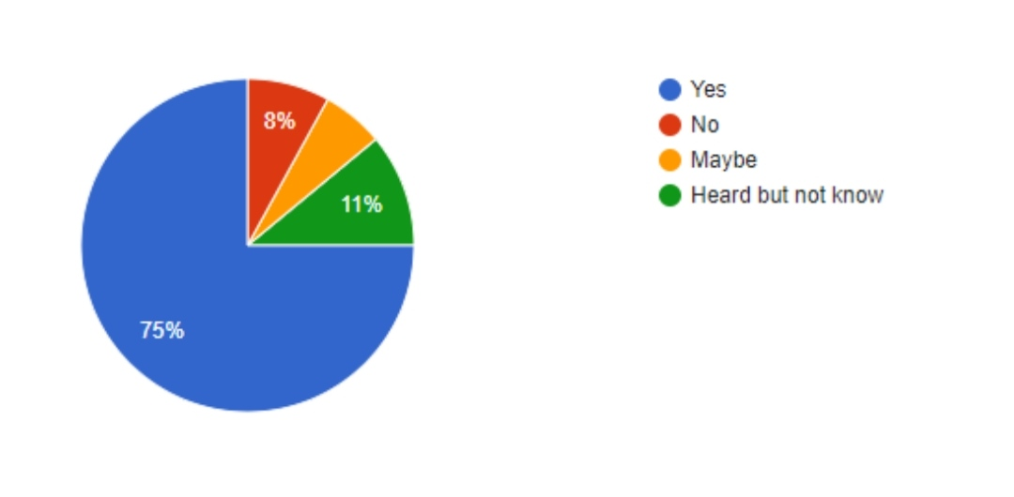

Interpretation: -

From the above analysis we can see that 75% have heard about money market and knows about that, while there are 6% people who aren't sure about this, 11% people have heard about the term money market but have no knowledge about that and then about 8% of the respondents don't know anything about money market

4) How long would you like to hold your money market instruments?

| SR NO. | PARTICULARS | FREQUENCY | PERCENTAGE |
| --- | --- | --- | --- |
| 1 | LONG TERM  METOD | 78 | 78% |
| 2 | SHORT TERM  METHOD | 22 | 22% |

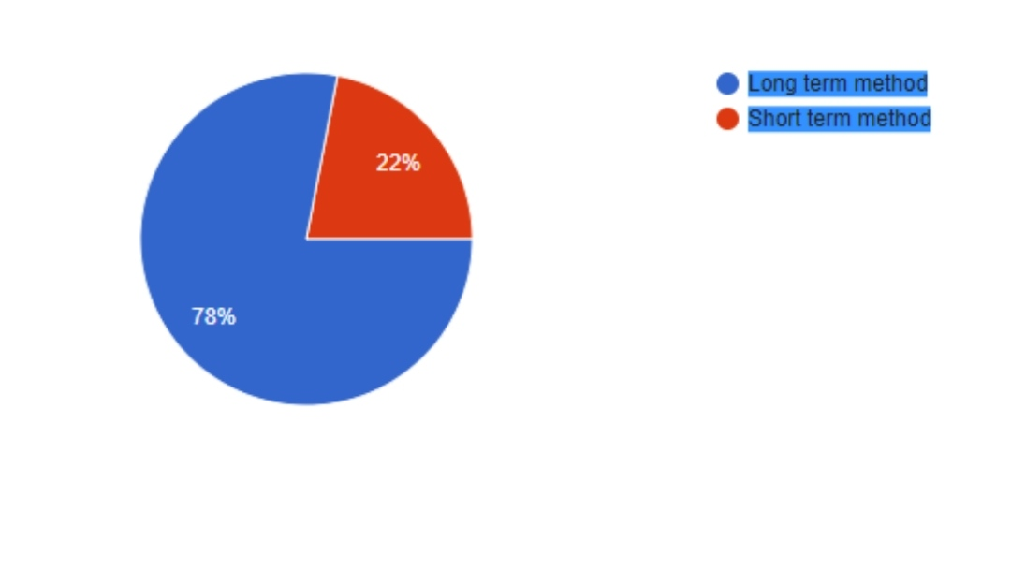

Interpretation: -

From the above data 78% of the people like to keep money market instruments for long term method while other people which are about 22 % keep it for the short-term method. We can see that most of them are willing to keep their investment for long term.

5) How much risk will you be willing to take?

| SR NO. | PARTICULARS | FREQUENCY | PERCENTAGE |
| --- | --- | --- | --- |
| 1 | LOW | 13 | 13% |
| 2 | AVERAGE | 19 | 19% |
| 3 | MEDIUM | 51 | 51% |
| 4 | HIGH | 17 | 17% |

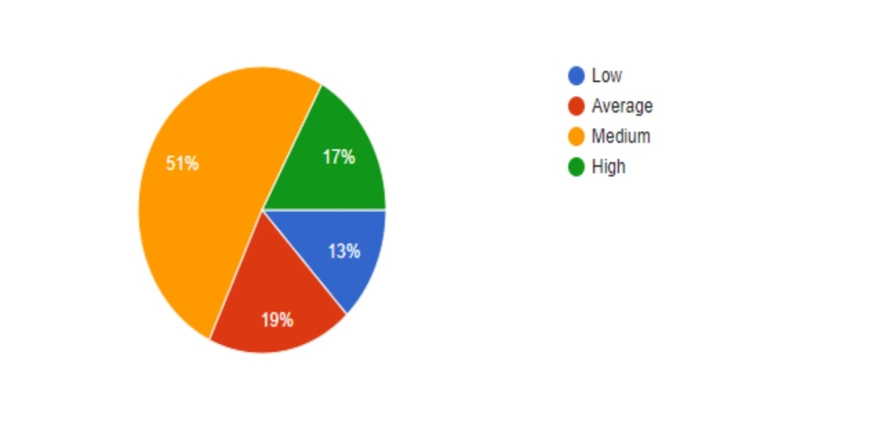Interpretation: -

From the above data we can see that 13% respondents will take low level of risk, while 17% of respondents will take high amount of risk. 19% of respondents will take risk at average level. Most of the respondents are willing to take average number of risks.

6) In your opinion what is your expected rate of return?

| SR NO | PARTICULARS | FREQUENCY | PERCENTAGE |
| --- | --- | --- | --- |
| 1 | BELOW 10% | 17 | 17% |
| 2 | BETWEEN 10  TO 20% | 32 | 32% |
| 3 | BETWEEN 20  TO 30% | 43 | 43% |
| 4 | ABOVE 30% | 8 | 8% |

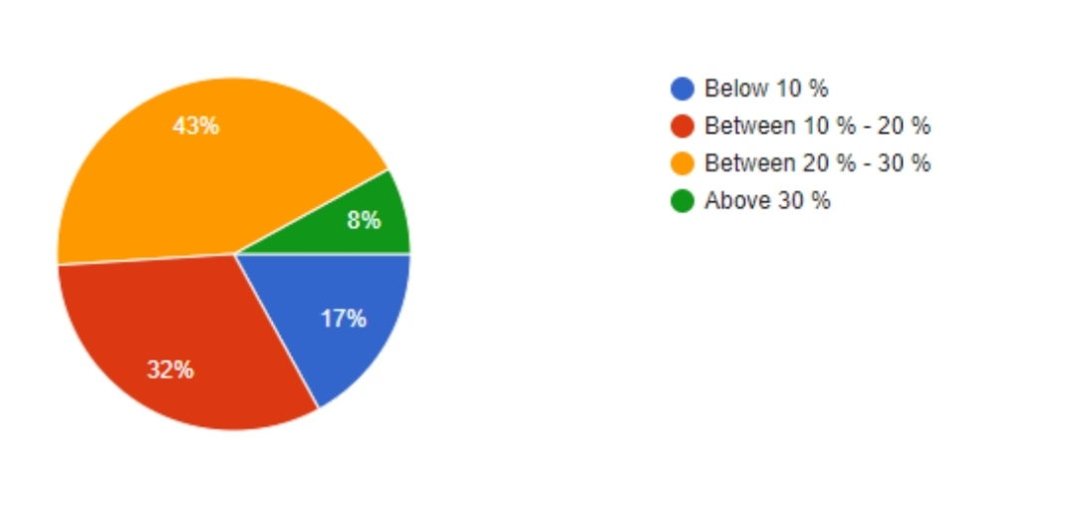

Interpretation: -

From the above data we can see that 17% respondents expect returns below 10%. 32% respondents expect Returns between 10%-20%. 43% respondents expect returns between 20%-30%. 8% respondents expect returns above 30%.

7) How would you rate your experience with Indian money market?

| SR NO | PARTICULARS | FREQUENCY | PERCENTAGE |
| --- | --- | --- | --- |
| 1 | AVERAGE | 18 | 18% |
| 2 | POOR | 10 | 10% |
| 3 | GOOD | 58 | 58% |
| 4 | EXCELLENT | 14 | 14% |

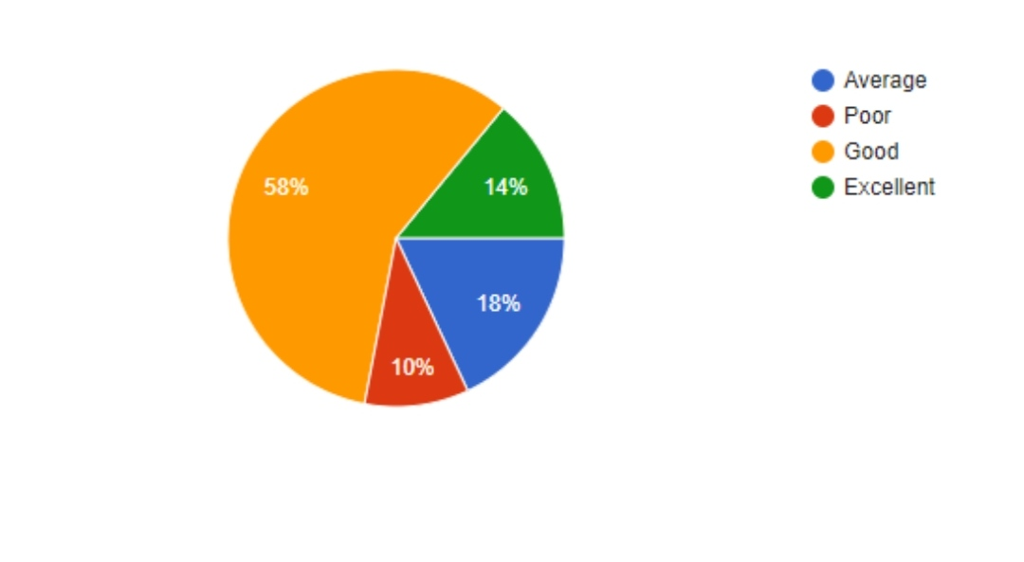Interpretation: -

From the above analysis we can see that 10% respondents didn't have a good experience with Indian market while 14% respondents had excellent experience with Indian Market.

8) Is recession had affected your investment decision?

| SR NO | PARTICULARS | FREQUENCY | PERCENTAGE |
| --- | --- | --- | --- |
| 1 | YES | 86 | 86% |
| 2 | NO | 14 | 14% |

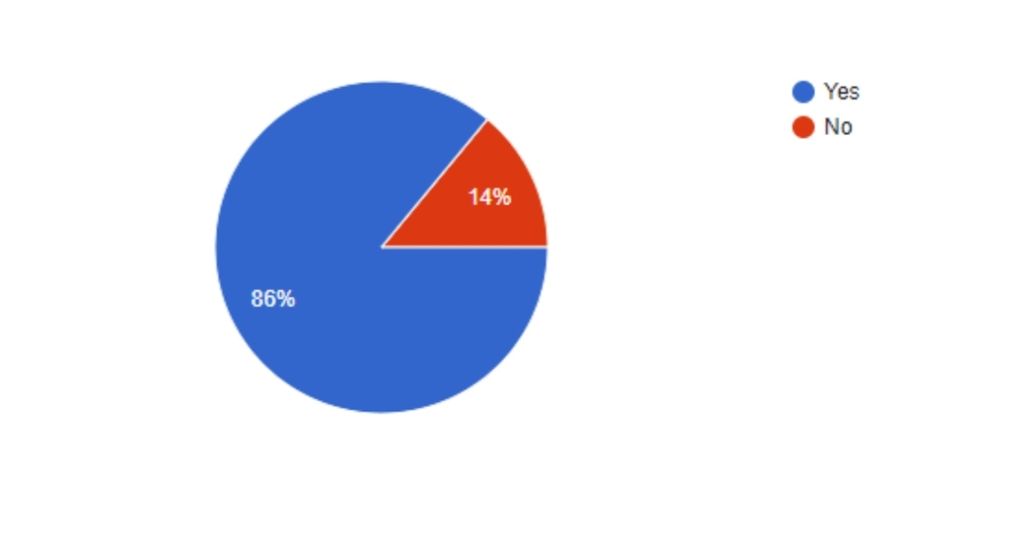Interpretation: -

From the above data we can see that 86% respondents experienced that recession has affected their Investment decision while 14% respondents were not affected by recession

9) For fixed income what type of instrument would prefer?

| SR NO | PARTICUL-ARS | FREQUEN-CY | PERCENTA-GE |
| --- | --- | --- | --- |
| 1 | Corporate Bond | 51 | 51% |
| 2 | Treasury Bills | 57 | 57% |
| 3 | Government  Securities | 53 | 53% |
| 4 | Commercial  Papers | 47 | 47% |

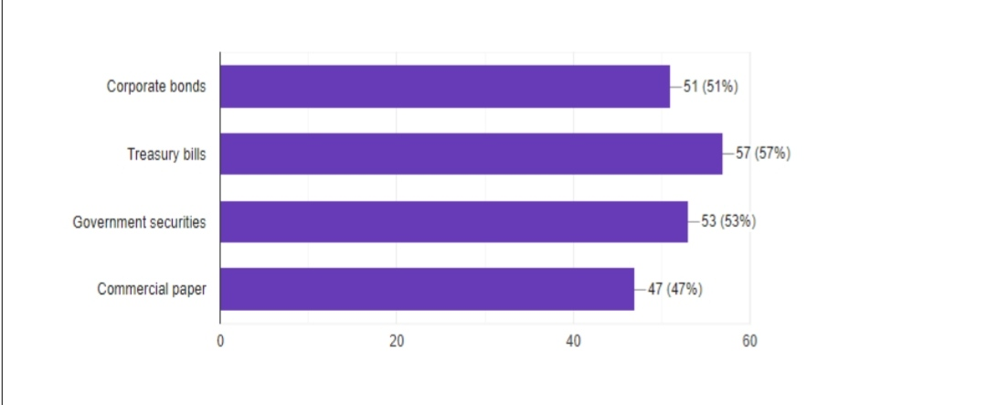

Interpretation: -

From the above data we can see that 51% of respondent invest in corporate bonds, 57% in treasury bills, 53% in government securities and 47% of respondents invest in commercial paper.

10) What will be your course of action during recession?

| SR  NO | PARTICULARS | FREQUENCY | PERCENTAGE |
| --- | --- | --- | --- |
| 1 | Buy | 39.2 | 39.2% |
| 2 | Sell | 23.7 | 23.7% |
| 3 | Hold | 37.1 | 37.1% |

|  |
| --- |
|  |

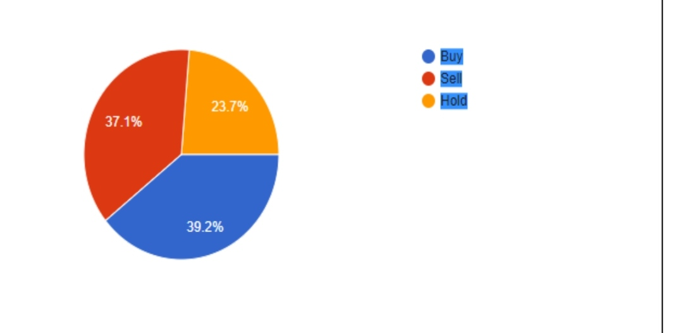

Interpretation; -

From the above analysis we can see that 39.2% of the respondents buy the instruments at the time of recession,

37.1% of the respondents sells the instruments, and 23.7% of the respondents hold the instruments

Questionnaire: -

Respected sir/ madam

I SHIVANI student of BBA in Finance, pursuing a research project on “A STUDY ON INDIAN MONEY MARKET”.

I will grateful to you if your valuable time & efforts with your valuable views on the subject of this research study.

1. NAME..............................................
2. AGE...................................................
3. ADDRESS…………………………….
4. Phone number……………………….
5. Occupation…………………………

1) What is your annual income?

a) Below 1 lakh.

b) Between 1 lakh to 3 lakhs.

c) Between 3 lakhs to 5 lakhs.

d) Above 5 lakhs.

2) How do you invest your saving?

a) Invest in capital market.

b) Invest in money market mutual fund.

c) Invest in banks.

d) Invest in real estate.

3) Do you have any knowledge of money market instruments?

a) Yes

b) No

c) Maybe

d) Heard but didn’t know

4) How long do you like to hold your money market instruments?

a) Long term method

b) Short term method

5) How much risk will you be willing to take?

a) Low

b) Average

c) Medium

d) High

6) In your opinion what is your expected rate of returns?

a) Between 10%

b) Between 10%-20%

c) Between 20%-30%

d) Above 30%

7) How would you rate your experience with Indian money market?

a) Average

b) Poor

c) Good

8) Is recession had affected your investment decision?

a) Yes

b) No

9) For fixed income what type of investment would you prefer?

a) Corporate bond

b) Treasury bill

c) Government securities

d) Commercial paper

10) What will be your course of action during re**c**ession?

a) Buy

b) Sell

c) Hold

